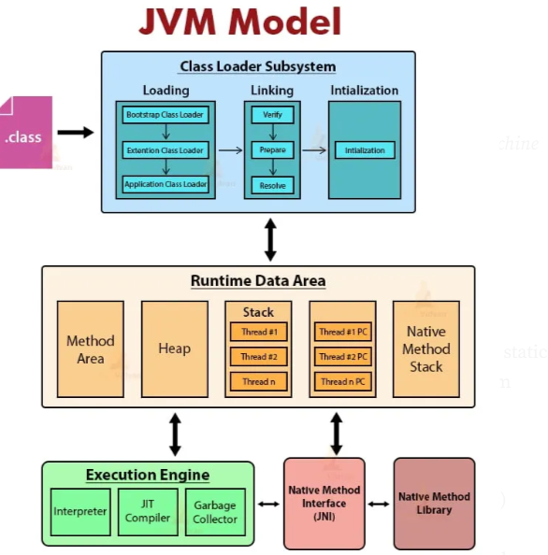

WORKING OF JVM :

STEP 1 — Compile (javac)
javac Demo.java → Output:
Demo.class
❗ Important:
This .class file contains bytecode, NOT machine code.
Only the JVM understands bytecode.
Q: Why is Java platform independent?
A: Because .class file is independent of OS/CPU.

STEP 2 — Run (java Demo)
At this moment JVM wakes up.
What does JVM contain?

🔥 JVM = 3 Major Components
- Class Loader Subsystem
- Runtime Data Areas (Memory Model)
- Execution Engine

🚀 CHAPTER 2 — Class Loader (Loading → Linking → Initialization)
When you run:
java Demo
JVM begins:

✔ Step 1: Loading
JVM loads Demo.class into memory.
It ALSO loads:
- Object.class
- String.class
- System.class
- PrintStream.class
- And all referenced classes
Everything into Method Area.

✔ Step 2: Linking
Linking = Verify + Prepare + Resolve

🔹 a) Verify
JVM checks:
- Is bytecode safe?
- Any illegal instructions?
- Access permissions valid?

🔹 b) Prepare
JVM allocates memory for:
- Static variables
- Default values (0, null, false)

🔹 c) Resolve
JVM converts symbolic references → direct memory references.

✔ Step 3: Initialization
JVM executes static blocks and static variable assignments in order.
Example:
static int a = 5;
static { System.out.println("init"); }

🚀 CHAPTER 3 — JVM MEMORY MODEL (Most Important Chapter)
You MUST visualize JVM memory like this:
-----------------------------------------
| METHOD AREA |
| (Class metadata + static + constants)|
-----------------------------------------
| HEAP |
| (Objects, arrays, String pool) |
-----------------------------------------
| STACK |
| (Method frames per thread) |
-----------------------------------------
| PC REGISTER (per thread) |
-----------------------------------------
| NATIVE METHOD STACK |
-----------------------------------------
Let’s deeply understand each:

🔥 1. METHOD AREA
The home of:
- Class metadata (Demo, String, Object...)
- Static variables
- Static methods
- Constant Pool
- String Literal Pool
📌 This is why static is shared across all objects → stored in Method Area.

🔥 2. HEAP
All objects go here:
Demo d = new Demo(); // object created in heap
Heap contains:
- Objects
- Object fields
- Array objects
- String objects (literals + new String())
- Collections (ArrayList, HashMap...)
📌 Heap = Shared memory between threads
This is why race conditions occur.

🔥 3. STACK (Per thread)
Each method call creates a Frame:
Frame:
- Local variables
- Operand stack
- Return address
Example:
int x = 10;
Demo d = new Demo();
Memory:
STACK (inside main frame)
-------------------------
| x = 10 |
| d = ref_to_heap_obj |
-------------------------
d is NOT the object.
d is only a reference (address).
Actual object is in HEAP.

🔥 4. PC REGISTER
Stores the next instruction of the current thread.

🔥 5. Native Method Stack
Used when Java calls C/C++ code via JNI.

🚀 CHAPTER 4 — What Happens When You Create an Object?
Demo d = new Demo();
Flow:
1. Class Loader ensures Demo.class is loaded
2. Heap allocates memory for object
3. Constructor runs (inside stack)
4. Reference (d) points to heap object
Memory View:
HEAP:
DemoObject@1234
-- fields --
x = ?
y = ?

STACK:
d ---> DemoObject@1234

🚀 CHAPTER 5 — How a Method Call Works?
public void foo() {
int a = 20;
}
When foo() is called:

JVM creates:
New Stack Frame:
--------------------
| Local var: a = 20 |
--------------------
When method ends →
Frame destroyed →
Variable “a” disappears.
📌 Objects survive in heap until GC removes them.

🚀 CHAPTER 6 — Why JVM Model Is The Root of All Java Concepts

✔ Why String is immutable?
Because String literals are stored in String Pool (Method Area).
Immutability allows sharing.

✔ Why HashMap needs hashCode()?
Because objects live in Heap →
HashMap stores buckets →
Hash = memory distribution.

✔ Why recursion causes StackOverflowError?
Because stack frames are limited.

✔ Why static belongs to class not object?
Because static lives in Method Area.

⭐ Step 1 — Know the 3 Main Class Loaders

✔ 1. Bootstrap ClassLoader
- Written in C
- Part of JVM
- Loads core classes:
java.lang.*, java.util.*, java.io.*

✔ 2. Extension / Platform ClassLoader
- Loads JDK optional libraries
- Example: javax.*

✔ 3. Application ClassLoader
- Loads your classes
- ClassPath jars
- /bin, /target, etc.

✔ Visualization:
[Bootstrap Loader]
|
[Platform Loader]
|
[Application ClassLoader]
|
[Your .class files]
This is called Parent Delegation Model.

Class is Loaded Only ONCE
Example:
Demo d1 = new Demo();
Demo d2 = new Demo();
Demo d3 = new Demo();
ClassLoader loads Demo.class only the first time.
Objects are created again and again in heap

MEMORY RULES (You MUST remember):

✔ Local variables (primitives + references) → stack

✔ Objects → heap

✔ Static → method area

✔ String literals → string pool

✔ Each thread has ITS OWN stack

✔ All threads share heap

MODULE 4 — GARBAGE COLLECTOR (GC INTERNAL WORKING)
GC lifecycle:

⭐ 1. Mark
GC marks objects that are reachable from:
- stack references
- static references
- active threads
Unmarked = garbage.

⭐ 2. Sweep
GC removes unmarked objects
- frees memory
- updates free lists

⭐ 3. Compact (in some GC algorithms)
Moves objects together to avoid fragmentation.

How JVM Runs Bytecode (Execution Engine)
The Engine has:
- Interpreter
- JIT compiler
- Profiler
This is why Java starts slow but becomes fast.

MODULE 1 — HEAP ARCHITECTURE (Deep Visualization)
HEAP
-----------------------------------------------
| Young Generation |
| --------------------------------------- |
| | Eden Space | Surv1 | Surv2| |
| --------------------------------------- |
-----------------------------------------------
| Old Generation |
-----------------------------------------------
| Metaspace |
-----------------------------------------------

JIT COMPILER + HOTSPOT OPTIMIZATIONS
Java uses an interpreter + compiler (JIT) at the same time.

✔ Interpreter → runs bytecode line by line

✔ JIT → compiles hot methods into machine code

FINAL SHORT SUMMARY

✔ ClassLoader
- 3 loaders: Bootstrap → Platform → App Loader
- Uses parent delegation
- Loads class once
- Goes through: Loading → Linking → Initialization

✔ Heap Architecture
- Young Gen (Eden + S0 + S1)
- Old Gen (long-lived objects)
- Metaspace (class metadata)
- Objects born in Eden → move to survivor → promoted

✔ Stack
- One per thread
- Stores local variables + method frames

✔ Object Structure
- Header (Mark Word + Klass pointer)
- Fields
- Padding

✔ Object Creation
- Class loaded
- Allocate in heap or TLAB
- Zero initialization
- Constructor call
- Reference stored in stack

✔ GC Basics
- Minor GC → Young Gen (fast)
- Major GC → Old Gen (slow)
- G1 GC uses regions + concurrent marking

✔ JIT Compiler
- Turns hot bytecode into machine code
- Optimizations: inlining, escape analysis, dead code removal

✔ Escape Analysis
If object doesn’t escape method → allocated on stack.

1What happens when you run a Java program (java Demo)?

✅ Short Answer
JVM loads Demo.class → verifies → executes main method using stack frames and heap memory.

🔥 Deep Answer
- java Demo starts JVM
- ClassLoader loads Demo.class
- Linking → verify bytecode, prepare static fields, resolve references
- Initialization → run static blocks
- JVM creates main thread + its stack
- Execution Engine interprets bytecode → JIT compiles hot parts
- Objects created on heap, references on stack
- Garbage Collector handles unused objects

2What is the ClassLoader hierarchy?

Short:
Bootstrap → Platform → Application.

Deep:
- Bootstrap loads core JDK classes (java.lang., java.util.)
- Platform loads JDK extensions (javax.*, etc.)
- Application loads your project classes
- Works through Parent Delegation → children ask parents first
- Prevents malicious class shadowing

3Explain Class Loading phases: Loading, Linking, Initialization

Short:
Load → Verify + Prepare + Resolve → Run static initializers.

Deep:
- Loading: find .class → create Class object
- Verify: bytecode validity
- Prepare: static fields allocated with default values
- Resolve: symbolic → direct memory references
- Initialization: static blocks + static field values applied

